   1. Read the poem and annotate it for how language is used to help us understand Ravi.

**Ravi**

Ravi is a good influence on Erik because…

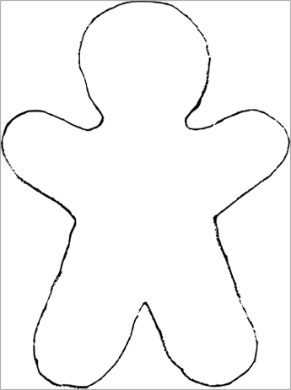**2. Outside** of the outline of Ravi, write **quotations** about his appearance​. **Inside** the outline of Ravi, write **quotations** his personality​

